Electrical contractors for domestic, commercial, industrial and agricultural premises

24 hr call out

Small, friendly, family-run business Est. 2006

No job too small

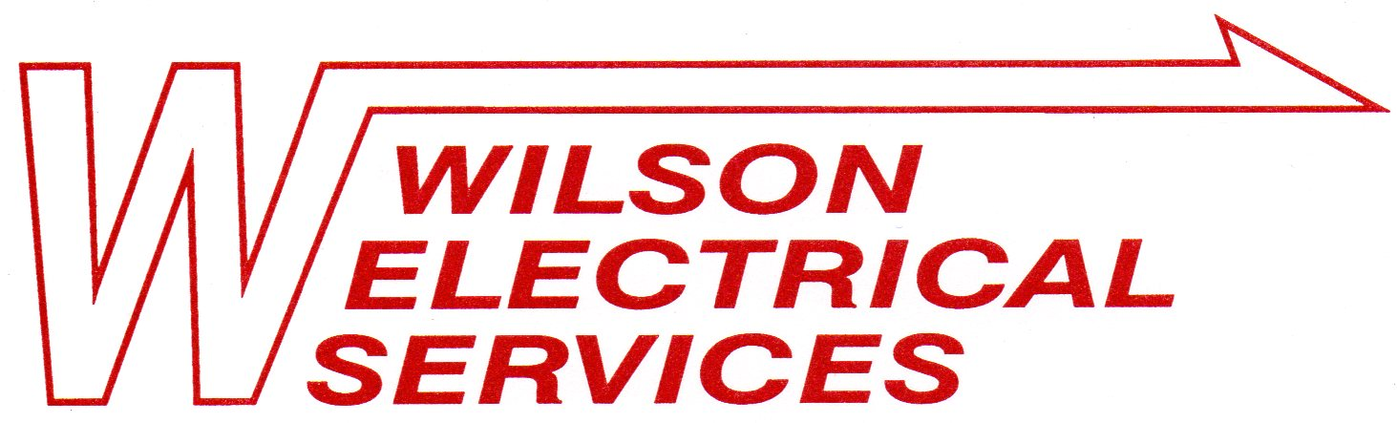
Contact Helen: 01949 860889 or Damian: 07901 711225

